Auction / Lottery Block Due July 15, 2024
Pumpkin Short Scrappy Block

Make one block for auction OR make two blocks and be eligible for the lottery block drawing. The drawing to win the second set of blocks will be held at the Guild meeting the night of the block due date.

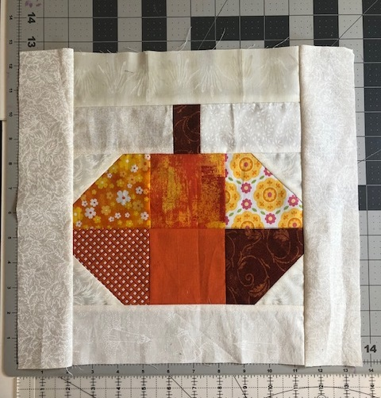
Due | July 15, 2024 at the Guild meeting
Pattern | Pumpkin Short Scrappy Block
Block Size | 13 ½ wide x 12 ½ tall unfinished
Color | Scrappy pumpkin color fabrics  Pumpkin stem fabric scrap  White or light print background colors

Figure | Color / Fabric | Cutting Instructions
A | Scrappy pumpkin color fabrics | Cut six, 3 ½ inch squares
B | Green, brown or B&W print for stem | Cut one, 1 ½ inch x 2 ½ inch rectangle
C | Background | Cut two, 2 ½ x 4 ½ inch rectangles
D | Background | Cut four, 2 ½ squares
E | Background | Cut two, 2 ½ inch x 9 ½ inch rectangles
F | Background | Cut two, 2 ½ inch x 12 ½ inch rectangles

Assemble figure B stem and figure C background rectangles into stem unit.

Assemble figure A pumpkin using 3 ½ inch squares into pumpkin unit.

Draw diagonal line on figure D background squares.

Stitch figure D background squares to opposite corners of pumpkin unit.

Stitch Stem unit to pumpkin unit.

Stitch figure E background rectangles to top and bottom edges of pumpkin unit.

Stitch figure F background rectangles to sides of pumpkin unit.

