**LQG Auction / Four Patch Flower Lottery Block**

Make one block for the auction or make two blocks and be eligible for the lottery block drawing! The drawing to win the second set of blocks will be held during the Guild meeting on the night of the block due date.

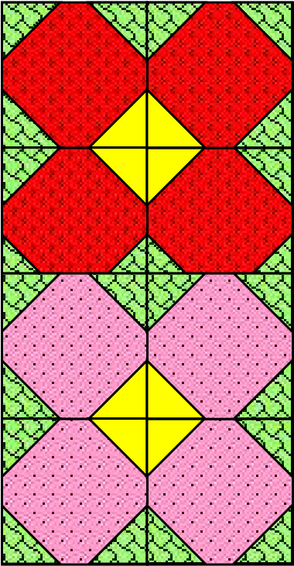

|  |  |
| --- | --- |
| Pattern | Four Patch Flower |
| Block Size | 8½” x 8½ unfinished  8” x 8” finished |
| Colors | Spring flower colors and green background |

|  |  |  |
| --- | --- | --- |
| Fabric | Color / Fabric | Cutting Instructions |
| A | Green Background (leaf) | Cut (12) 2 “ squares |
| B | Yellow (flower center) | Cut (4) 2 “ squares |
| C | Flower prints or contrasting leaf prints | Cut (4) 4 ½ " squares |

Sewing Instructions:

1. Draw a diagonal line on the wrong side of the 2” squares. Sew 3 green and 1 yellow on each “flower” square on opposite corners (see diagram).

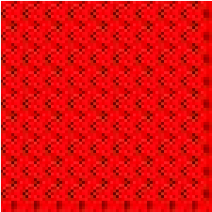

Sewing Line

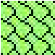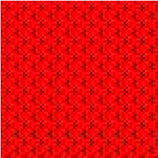

1. Trim away excess fabric leaving a ¼ “ past the seam and press towards the corner.
2. Assemble blocks as shown below with squares to create flower block.

