**LQG Lottery HEART BLOCK**

Make ONE block or make TWO blocks AND be eligible for the lottery block drawing! The drawing to win the second set of blocks will be held at the Guild meeting the night of the block due date. Instructions can be seen at [www.lakeviewquiltersguild.org](http://www.lakeviewquiltersguild.org).

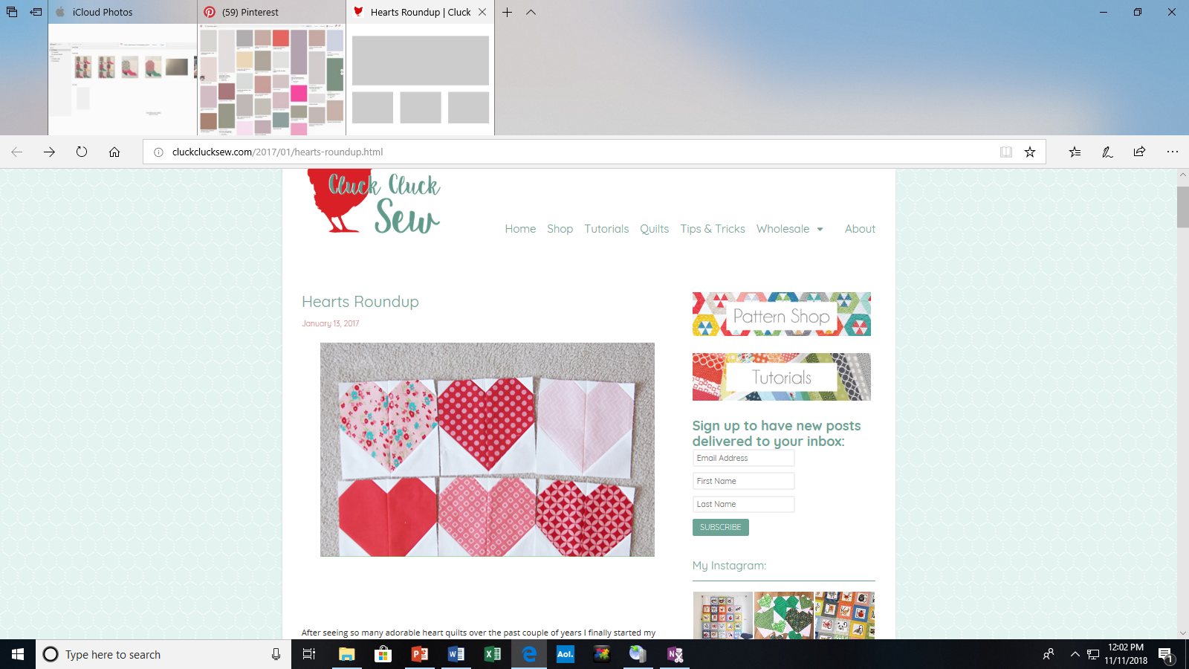

|  |  |
| --- | --- |
| Pattern | Heart |
| Block Size | 8 1/2” x 8 1/2” with seam allowances  8” x 8” finished |
| Colors | Red / or Pink Solid or Print  White or white on white background |

Cutting instructions for **ONE** block:

|  |  |  |
| --- | --- | --- |
| Color | **Number to cut** | **Size** |
| Background - white or white on white (print or solid) | 4 | 1 1/2” squares |
| 2 | 4 1/2” squares |
| Heart – Red or Pink (print or solid) | 2 | 4 1/2" x 8 1/2" rectangles |

**Sewing Instructions:**

1. Place a 1 1/2” square (white) on each top corner of each 4 ½” x 8 1/2" rectangles of heart (red) fabric.

1. Sew diagonally as shown.

Trim to 1/4 " seam and press.

1. Place one 4 1/2” square (white) of each rectangle lining up the edges.

Mark a line diagonally across the center of the square. Stitch on the

drawn line. BE SURE TO FOLLOWING THE THIS ILLUSTRATION

when positioning the squares before sewing on the line.

Cut 1/4" from the sewn line and press. *Please*

*make sure you are cutting on the correct side of*

*the seams, before actually making the cut.*

1. Layout the units as shown. Sew together and press.

5. Square up the block to 8 ½ by 8 ½